Fundamentals and Development of Self-Driving Cars

Yoganandhan Anbu1, Subhash Sd1, Hebinson Jothi2, Jagadeeshwaran Hari3

1Department of Mechatronics Engineering, Chennai Institute of Technology, India

2, 3Department of Mechatronics Engineering, Chennai Institute of Technology, India

[praviinvj@gmail.com](mailto:praviinvj@gmail.com) , [subhashsd73@gmail.com](mailto:subhashsd73@gmail.com)

**Abstract** – This paper presents detailed information on the constitutional and development of self-driving cars. For a decade, in the automotive industry, there are lots of malfunctions are performed.  It makes many issues like accidents, driver’s liability and much more.  These kinds of problems arise when the human interface with the car.    In real-time Self-driving cars that are driven by digital technologies without using a human interruption. Based on the fundamentals of developing self-driving cars are totally by sensing their environment and automating tasks.  In our proposed system the Localization, Perception, Prediction, Planning, and Control are to makes define and governing the car, certain algorithms are used to control that autonomous system and are used for steering functions. The autonomous car can predict and cruise its path and traffic signs as well as pedestrians. It can minimize accidents, fuel rates, and parking space.

**Keywords** – *Driving assistance system, Fundamentals of self-driving cars, Introduction to Self-driving cars, Localization, Perception, Intelligent vehicles*

**Introduction**

The self-driving car, are also known as Autonomous driving system or driverless cars, a vehicle that is capable of sensing its environment and moving with define lane without human interaction. Self-driving cars technologies mostly involve the computer system by automating vehicle control parts. These technological parts possess a range of competencies, from forward-collision warning and antilock brakes to lane-keeping and adaptive cruise control, to fully automated driving, Autonomous cars combine the variety of sensors, actuators, and cameras. The benefits of automated cars are predicted to increase traffic flow and provide enhanced mobility for all users. The basic fundamentals are in High definition maps, Localization, Perception, Prediction, Planning, and Control of vehicle as follows.

**Origin**

The first era of self-driving cars started in the 1920s. There is a lot of development and creating new technology in the later 1960s. The ALV projects were conducted by the Robotics Institute of Carnegie Mellon University NavLab. By 1994, the double robot vehicles called Vita-2 and VaMP of Daimler-Benz and Ernst Dickman’s demonstrated autonomous driving in free lanes. In 2004 the DARPA (The Defense Advanced Research Projects Agency) conducted the challenge

To self-driving cars to complete the course, But no one did that. In 2005 the second challenge was conducted in that Sebastian Thrun led his team to have completed the course. The fully efficient self-driving car was introduced by Toyota Prius modified with Google’s experimental driverless technology was licensed by the Nevada Department of Motor Vehicles in May 2012. The first license issued in the United States for a self-driving car.

**Levels of Automation**

There are five levels of automation systems that enhanced the self-driving system.

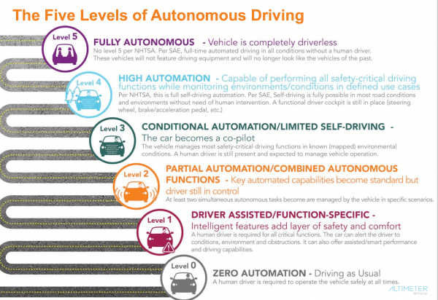

The zero automation is a base level automation system it was a soul decision matter Human driving system. The first level automation is driver assistance, some intelligent aspects were included in it, and the driver was semi-engaged. The second level of automation is partial the automatic cruise control and Automatic lane-keeping system. The third level is conditional automation, Human interface is needed whenever necessary. The fourth level is High-level automation, there is no human interface. The fifth level is a fully autonomous Vehicle that no human and his interface are not needed.

**High-Definition Maps**

The High-Definition maps are not like Normal maps or route maps. The HD maps are more important for self-driving cars. They have a higher level of accuracy of objects, lanes, and locations up to 10cm. It contains a huge amount of driver assistance information, Three-dimensional representation of road network, layouts intersection, and location of the signboards. It helps to solve the localization problem, figuring out where exactly the car in the world. It also recognizes the shape of objects. HD maps are a core of self-driving cars.

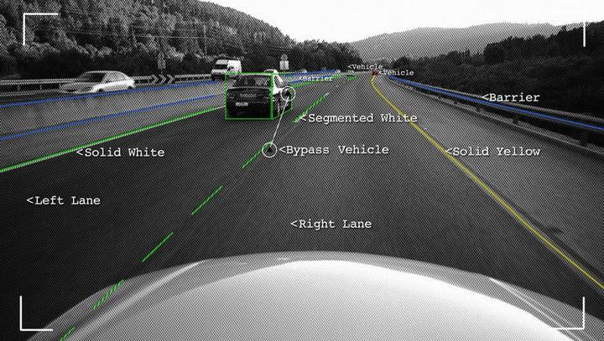

The preprocessing and coordinate transformation needs to collect data and compare it with HD maps. The uniform coordination system is used in most vehicles. The *Region of Interest*, the purpose of this section is to build a program that can easily identify the lane lines in a picture or a video frame from the camera. In that we have to convert this image in grayscale is that processing a single channel is much faster than three channels RGB and is less computation intense. Planning with maps and planners identify possible routing options. The Maps are also containing information related to the source of data which sensor was used to get the information when the map was last updated.

**Localization**

Localization means the car was wherein an exact location. The sensor and the maps are collecting the data to find an exact location. The vehicle coordinate frame and map coordinate frame are vice-versa.

**A) GNSS-RTK**

The GNSS is known as the *Global Navigation* *Satellite System,* There are 30 GPS satellites operating in outer space in a given time each was located on 20,000 kilometers away from the surface of the earth. The control system is specified around the earth for controlling satellites. The RTK is called a *Real-Time Kinematic* positioning system is also a satellite navigation system used to precision position data from a satellite-based positioning system. But the RTK based system was being issued with tall buildings. It was also low-frequency updates like 10MHz. The GPS that equipped in the car can update its location in 0.1 seconds.

**B) Inertial Navigation**

An Inertial navigation system is a navigational device that uses a computer, motion sensors (accelerometers) and rotational sensors (gyroscopes).

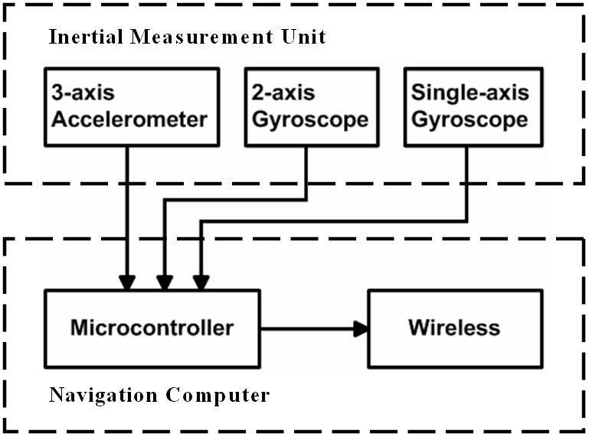

That can be continuously calculated by dead the action or process of calculating the position, the orientation and the velocity (direction and speed of movement of vehicles)

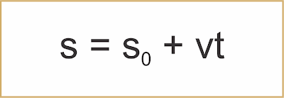

**S0 = Initial Location**

**V = Velocity**

**T = Time Taken**

We are using a 3-axis accelerometer to define the acceleration of the car at any point of the time and also measure the velocity of the current position. Gyroscopes are used to measuring the relative position of the spin axis and the three external Gimbals to measure *initial measurement unit* IMU.

**C) LIDAR Localization**

LiDAR (Light Indication Detection and Ranging) a means of point cloud matching. This method continuously matches the detected data from the Lidar sensor with HD maps. There are many algorithms to matching the point of clouds. *Iterative closet point* ICP is the first approach, filter algorithms are another approach of Lidar localization.

**Kalman Filter** is an algorithm is used to find assume state which was based on the last state in new sensors measurements.

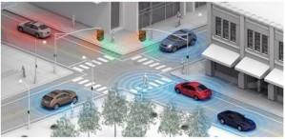

An extended *Kalman filter* algorithm is to pose by registering 3D point clouds against *Gaussian* mixture multiple solution-maps. This method was proposed on two driverless cars in terrible weather conditions and presented localization estimation errors of about 0.15 m.

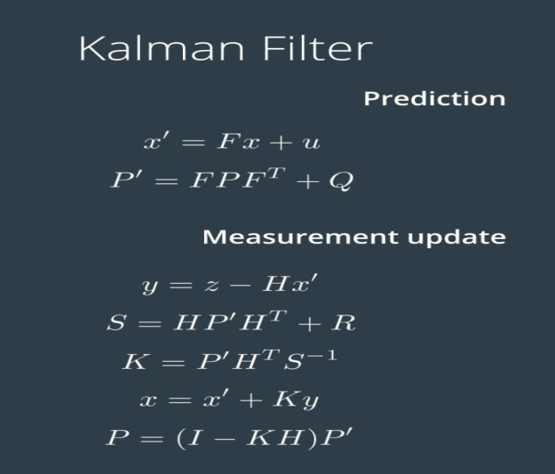

In a statistical method of the control system, the Kalman filtering is also called as *Linear Quadratic* *Estimation* (LQE), this type of algorithm that uses a series of measurements observed over time, and contains other inaccuracies and unknown variables.

**E) Camera-Based Localization**

In camera-based localization in self-driving cars is used to estimate the location of the car and relative to the map. A *Recursive Bayesian* filter algorithm is used to perform to find inferences in a graph by exploiting its structure and the model of how the car moves, as measured by the visual odometry.

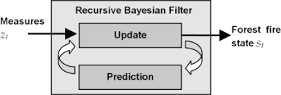

This algorithm is able to point out the car’s position in the graph and increase the probability that the current pose lies in a point graph that is correlated with the latest car movements.

**Perception**

Perception is a tough task in controls of the self-driving cars. The perception module has been upgraded completely to handle comprehensive sensor fusion of sensors.

The perception module incorporated the capability of using multiple cameras, radars, and Lidar to recognize obstacles and fuse their individual tracks to obtain in final tack list from the controller. The obstacle, sub-module detects, classifies and tracks obstacles. The sub-modules are also predicted obstacle motion and position information. For lane-keeping, we had lane instances by post-processing lane parsing pixels and calculate the lane relative location to the vehicle.

The core concepts of self-driving cars are Detection, Classification, Tacking, and Segmentation. *Detection* in the means of detects the object the capture images by cameras or the Lidar inputs. *Classification* is a process done by some Neural Network algorithms and classifies in certain manners. The *Tracking* in the means of the tracks the objects from the car like and their velocity, distance, and some other aspects. The *Segmentation* in the means of clarifies each pixel form the camera images and semantic category.

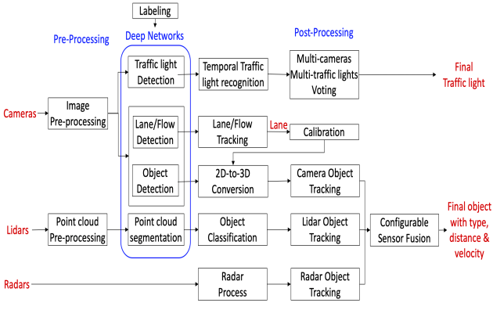

**A) Camera Images**

The camera images are the common data; the images are comprised of pixels. Which called small units of color, in every pixel of an image, is just a numerical value, that values are comprised into an image matrix.

Color Images are more complex. Color images are constructed as Three-Dimensional cubes of values each cube is a Height, Width and the Depth of the value.

**B) LIDAR Images**

The Lidar images are getting from the sensor which creates the point cloud on the environment and defines the objects around it. The Lidar works by the laser are coming out of it and getting back with the modified frequency that makes it measure distance.

**C) Machine Learning**

Machine Learning is extremely used to find out the solution to various problems that arise in the manufacturing of self-driving cars. With the inclusion of sensor data processing in an *Electronic Control Unit* (ECU) in a car, it’s essential to enhance the utilization of machine learning to accomplish new tasks.

The **Supervised Algorithms** make a training dataset to learn and they continue to learn till they get to the level of confidence they aspire to reduce the probability error. Supervised learning is also sub-categorized into regression, classification, and detection or dimension reduction.

**Unsupervised** **Algorithms** are another set of machine algorithms that fall between unsupervised and supervised. There is a target label in supervised learning; there are no labels in unsupervised learning, the **Reinforcement** **learning** consists of time-delayed and sparse labels for future rewards.

**Regression** is also a kind of algorithm for predicting functions. The Regression Analysis evaluates the relationship between two or more variables to collate the effects of variables on distinct scales and is driven mostly by the metrics.

**Neural Networks**

An Artificial Neural Network is a tool to learn complex patterns of data. Neural Network is comprised of a large number of neurons. For neural networks the most basic representation of an image “The Pixel value of the Image”.

**A**) **Back Propagation**

The learning is also called Training. It was consists of the step cycle.

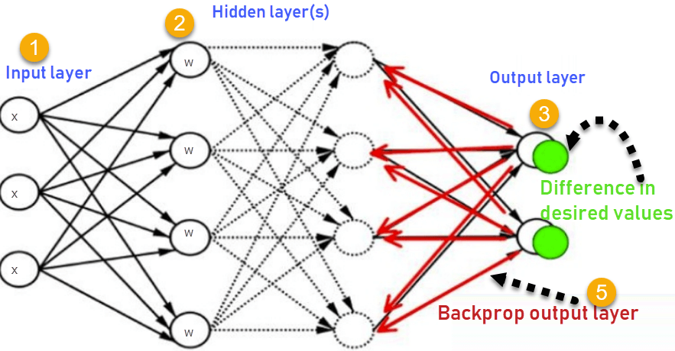

1. **Feed Forward** – Feed each image to Neural Network (n.n) to generate the output value.
2. **Error Management** – The difference between Ground Truth and generate the output value.
3. **Back Propagation** – We sent the error to back through the Neural Network feed to forward on the reverse.

**B) Convolutional Neural Network**

The Convolutional Neural Network is a perfect solution to the Perception problem. The input values for CNN are multi-dimensional values, Including two, and three-dimensional shapes that define most of the sensor data. Reshaping the Image Matrix into the *Vector Coloums* into a Giant *Row.*

**C) Region-Based Convolutional Network**

The Region-based Convolutional Network (RNN) gets the excellent object detection accuracy by the deep convolutional network to classify the object’s proposals. R-CNN has notable drawbacks.

**Training is a multi-stage pipeline**

R-CNN is work to fine-tune the ConvNet on object proposals using log loss. Then, it fits *Support Vector* *Machines* (SVM) to ConvNet features. These SVMs are acting as object detectors, replacing the softmax classifier learned by fine-tuning. In the third training stage, bounding-box regressors are learned.

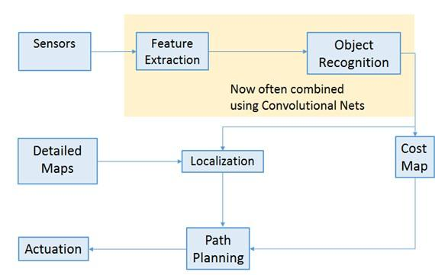

**Training is expensive in space and time**

For SVM and bounding box are the regression training, the feature is the extracted form each object proposal in each of the images and written to the output. The very deep neural network, such as the VGG16, in this process it takes a 2.5 GPU-days for the 5k images of the VOC07 travel set. These features require hundreds of gigabytes of memory and storage.

**Object detection is slow**

At last, test-time that features are extracted from eath object proposal in each test image, Detection with VGG16 takes 47s / image on a GPU.

**D) Tacking**

After detecting the object it has been in tracking. If we detect every object and every frame and identify each of the objects with the *Boundary Box*. If the identity gets the conformation if we match all the objects detected in the previous frame with objects. That object detects in the frame by finding objects with a higher similarity.

**E) Segmentation**

The semantic segmentation involves the classifying of each pixel of the image. *Fully* *Convolutional Network* (FNN). In that FNN is replaces the flat layers at the end of a traditional CNN architecture with convolutional layers. The first part of the network is called encoders and fetches on the input image. The second half is a decoder it applies to output.

**F) Region of Interest**

The region of interest which was based on the object detection on the read-data input to a point-cloud data.

1. **Single Shot Detector**

The SSD approach is based on the feed-forward convolutional network that produces a fixed-size collection of *bounding boxes* and scores for the presence of the object with the class instances in those boxes, it followed by a non-maximum suppression step to produce the final detections. The Early network layers are based on a standard architecture used for the high-quality image classification technology, which we will call the base network. We then add auxiliary structure to the network to produce detections with the following structures.

**Multi-scale feature maps for detection,** in that we add convolutional feature layers to the end of the truncated base network.

**Convolutional predictors for detection**, in this approach each added feature layers can produce a fixed set of detection predictions using a set of convolutional filters.

1. **You Only Look Once (YOLO)**

In this YOLO, a new type of a new approach detection technology in the self-driving cars. YOLO predicts multiple bounding boxes per grid cell. At training time we only want one bound in box predictor to be responsible for each product. First, YOLO is extremely fast in object detection technology. Since we frame detection as a regression problem we don’t need a complex pipeline. We simply run our neural network on an image at a test time to predict detections. Our base network runs at the 45 frames per second with no batch processing on the Titan X GPU a fast version runs more the 150 fps.

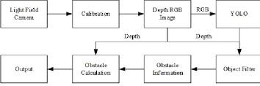

**Prediction**

The prediction module studies and predicts the behavior of all the obstacles detected by the perception module. Perception receives obstacle data along with basic perception information including positions, headings, velocities, accelerations, and generates predicted trajectories with probabilities for those obstacles.

Prediction needs to be real-time, latency as small as possible Accuracy, Predictions is also been valued on learning a new behavior of vehicles.

1. **Model-based Prediction**
2. **Driven-based Prediction**

**Model-Based Prediction**, one model describes the moment of a vehicle turning right. Another one that describes the movement of the vehicle on continuing straight.

**Data-Driven Prediction**, It was used by machine learning to train a model based on the observations once on the model is trained and make predictions in the real world.

**A) Lane Sequence-Based Predictions**

In the lane sequence-based predictions we have to divide the path into multiple segments.

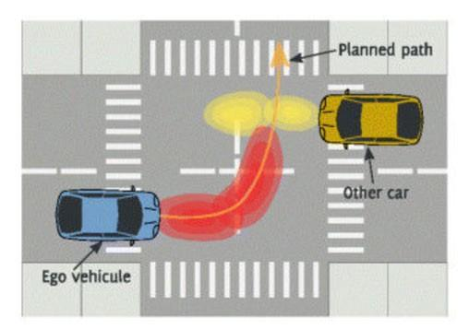

Autonomous vehicles are equipped with many advanced sensors that allow them to perceive other vehicles, obstacles, and pedestrians in the environment. If any obstacle status, we have knowledge on predict the state, Initially we have to know the state of an object.

The classical approach of probabilistic graphical models, such as *factors graph* *spatiotemporal graphs*, and the dynamic Bayesian networks, which bring graphical models into the sequential modeling space, is widely used in self-driving cars community for many reasons including their interpretability and the high-level structure, which can capture various relationships between features to modeling temporal sequences.

**B) Recurrent Neural Networks**

An approach that takes special advantage of time-series data (Back Propagation). Apart from its standalone utility. Input monolithic and relativity simple SSD model provides a useful building block for larger systems that employ an object detection component. A promising future direction is to explore its use as part of a system using Recurrent Neural Networks to detect and track objects in Video simultaneously.

**C) Trajectory Generation**

Trajectory planning was a final step of the prediction process. We can be getting constrains that will eliminate most of the candidate trajectories. We make an assumption that the car will align with the center to the target lane.

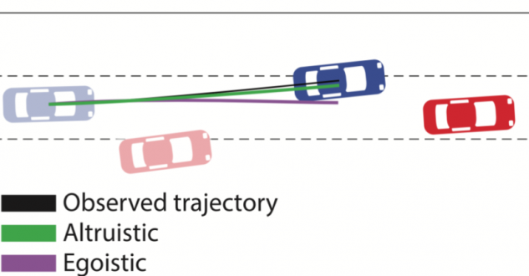

In that above figure, Path planning for autonomous vehicles becomes possible after technology considers the urban environment in a way that enables it to search for a path. Put, simply thread-life physical environment is transformed into a digital configuration or a state space. Path planning technology searches for and detects the space and corridors in which a vehicle can drive.

**Planning**

Planning is a base of Routing. The routing takes the map data as input and output a navigable path.

.

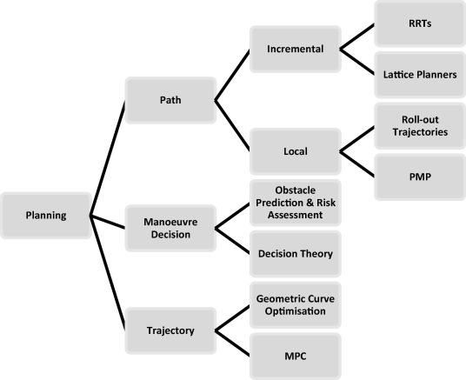

**A) Routing**

Which was planning to go from A to B. It needs two inputs

* Map
* Current position on map
* Destination

**Route Module,** Trajectory planning how we make subtle decisions to avoid obstacles and create a smooth ride for the passengers

**B) Graph Analysis**

The graph is not the state-space graph, In fact, unlike the state-space graph in which a plan is a path through the graph. The planning graph is essentially a flow in the network flow sense. Planning Graph is closer in spirit to the *Problem Space Graphs* (PSG).

Nodes – Section of Road

Edges – Connection between on those sections

**Constraints,** In the real world it were plenty of constraints, which was a major use of trajectory to a collision-free, obstacle-free passengers make to feel more comfortable.

**Frenet coordinates,** It helped us to describe the position of cars with respect to the road. **Trajectory Planning,** It was the most crucial moment of planning of the car the **Path-Velocity** decoupled planning.

* **Path-Planning**
* **Speed-Planning**

**C) Path Generation and Selection**

The path Generation and Selection is the next process after it defines all constraints, it was based on the position of the car.

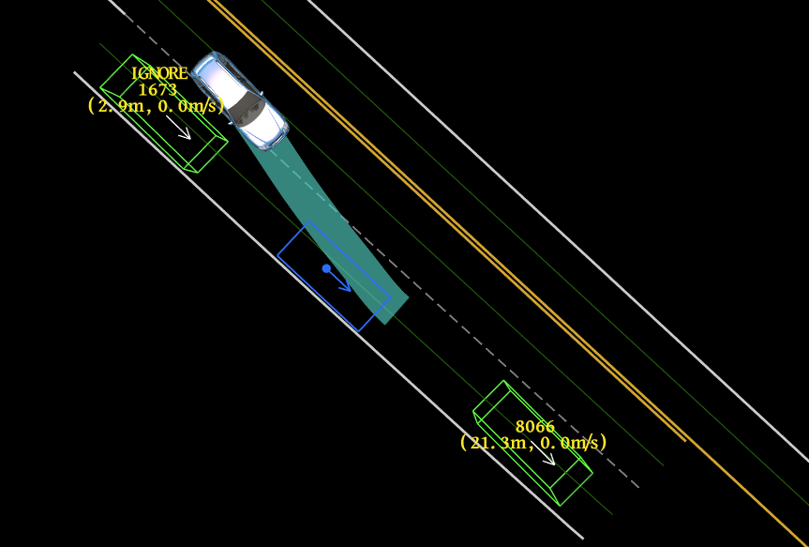

**D) Lattice Planning**

The trajectory was in implement in 3d representation longitudinal dimension, lateral dimension, time dimension.

* SL – Trajectory
* ST – Trajectory

**Control**

Control is the main strategy of actuating the vehicle to move it towards the road. The control inputs are Steering, Acceleration, Brake. It, especially for safety as planning and control the smoothness of driving, is the main option to control.

1. **PID – Proportional Integral Derivative**
2. **LQR – Linear Quadratic Regulator**
3. **MPC – Model Predictive Control**

**Control Pipeline**

Two inputs are aspects are *Target* *Trajectory* and the *Vehicle* *state*. The Target Trajectory comes from the planning module. Each point of trajectory as designates position (x, y) and velocity (*v)* and the acceleration of the car (a). The vehicle state determines the position of the vehicle by using the localization module. This gets data from the sensor in the steering, acceleration, and brake.

**PID Control**

The most important characteristic of autonomous vehicles is their safety and their ability to adapt to various situations and road conditions. We are comparatively comprised of three implementations of such controlling methods, a proportional-derivative (PD) controller built with in accordance with the sensors in steering, a PID controller as an extension of the steering control, a controller designed via the most versatile evolutionary computing methods.

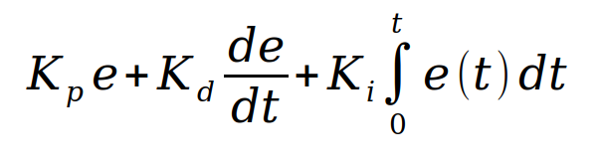

In the above equation that defines the PID controller, where Kp, Ki, Kd refers to *proportional*, *integral* and *derivative* gains constants respectively. For implementation in discrete form, the controller equation is modified by using the backward Euler method for numerical integration. The term which represents the sampling time ts is simply eliminated because of multiplication with constants values the PID gains Ki and Kd

**Linear Quadractive Regulator**

In Linear Quadractive Regulator method for constant and time-varying vehicle speed. The latter is implemented by using a simple gain scheduling method at the grid of the operating points.

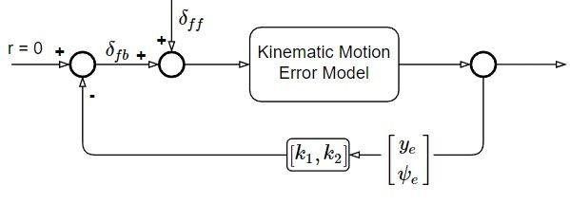

In the design of stabilizing LQR state space control coefficients (*k1, K2*) for the given linear system and obtain the time-varying controllers are different vehicle speed as (*k1*(*V*(t)), *k2*(*V*(t))) in Matlab.

**Model Predictive Control**

The MPC is an advanced method of process control that is used to control a process while satisfying a set of constraints. It can obtain further speedup by solving the planning problem approximately it can also fix barrier parameters and limit the total number of Net won steps. It can also run on **Kilohertz** rates.

**Conclusion**

This paper represents the detail information on fundamentals and development and major aspects of self-driving cars.  The framework formulates the problems that arrive from the automotive industries are makes major losses. The errors from the industry are non-predictable.  Multiple solutions from the different scenarios make that problem to clear. One of the main aspects is the era of self-driving cars is makes and successful experimental results show utility to this approach.  In recent days many companies involved in research and manufacturing of self-driving cars inefficient methods to solve various problems on certain aspects. In our work, we detailed the real-time self-driving cars and also about every circumstance clearly and also approach it in the right way.  For future work, the different technologies were implemented on further works to reduce difficulties.

**References**